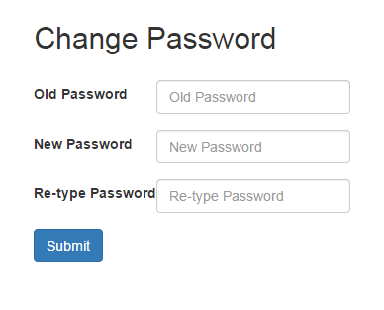

1. Old Password Field

* Description: This is where the staff input name for the new hall.
  + Action: User inputs the name of the hall.

1. New Password Field
   * Description: This is where the staff selects the Campus of the new hall.
   * Action: User clicks the campus of the new hall.
2. Re-type Password Field

* Description: This is where the staff inputs the capacity of the new hall
  + Action: User inputs the capacity of the new hall.

1. Submit
   * Description: Button
   * Action: Redirects to changePassword.php to update the database